Adrian Penalo
CUNY Brooklyn College
ECON 7091G: Independent Study
Professor Nadia Doytch
An Econometric Analysis of Cryptocurrency Price Drivers
EMPLID: 23534281

Abstract
This paper investigates the relationship between cryptocurrency price formation and a combination of macroeconomic indicators and token-level fundamentals. Using a cross-sectional dataset of 60 cryptocurrencies in the year 2020, the study employs an Ordinary Least Squares (OLS) regression model with log-transformed variables to explore the drivers of price variation. The results indicate that internal market dynamics—namely market capitalization, trading volume, and volatility—are significantly associated with price levels, while macroeconomic indicators such as the 10-Year Treasury Rate show limited explanatory power in a cross-sectional context. These findings suggest that token-specific characteristics are more influential than broad economic variables in shaping cryptocurrency valuations. The study concludes with policy recommendations for improved transparency, regulatory reporting standards, and enhanced investor guidance within the cryptocurrency ecosystem.
Introduction
The global financial system is undergoing significant transformation, driven in part by the rise of digital assets that challenge traditional notions of value, exchange, and monetary policy. At the forefront of this transformation are cryptocurrencies—decentralized, blockchain-based digital currencies that allow peer-to-peer transactions without reliance on central banks or financial intermediaries. Since the inception of Bitcoin in 2009, the cryptocurrency ecosystem has grown rapidly in both size and complexity. As of 2020, thousands of cryptocurrencies with diverse economic purposes, governance structures, and technological frameworks exist, forming a multi-trillion-dollar global market.
Bitcoin, the most well-known cryptocurrency, began as a decentralized payment system but has since evolved into a speculative asset and digital store of value. Similarly, Ethereum has enabled the development of decentralized applications (dApps) and smart contracts, paving the way for broader financial innovations such as decentralized finance (DeFi). The emergence of stablecoins like Tether and USD Coin further illustrates the diversity within the cryptocurrency space, offering price stability while maintaining blockchain compatibility. With growing interest from institutional investors, regulators, and financial technology firms, the role of cryptocurrencies in financial markets continues to evolve.
Despite the growing importance of cryptocurrencies, there remains limited empirical research on how they are priced in relation to both internal token dynamics and broader macroeconomic variables. Traditional finance literature has established frameworks for understanding how interest rates, inflation, and money supply influence equities, bonds, and fiat currencies. However, the application of these frameworks to cryptocurrencies is less straightforward, given their decentralized and speculative nature.
This study is motivated by the need to bridge the gap between cryptocurrency market behavior and established economic theory. Specifically, it seeks to answer the question: To what extent do macroeconomic indicators and internal token-specific variables explain variation in cryptocurrency prices? While some view cryptocurrencies as insulated from central bank actions, others argue that they serve as hedges against fiat devaluation or systemic risk. A deeper understanding of this relationship can inform investment strategies, regulatory decisions, and theoretical development in financial economics.
To address this question, the study employs a cross-sectional econometric analysis of 60 cryptocurrencies during the year 2020. By combining data from CoinGecko on token prices, market capitalization, and trading volume with macroeconomic indicators from the Federal Reserve Economic Database (FRED), this research tests the relationship between log-transformed price levels and a set of explanatory variables, including token volatility and supply growth.
The choice of 2020 as the year of analysis is particularly relevant. During this period, the world economy was disrupted by the COVID-19 pandemic, triggering unprecedented monetary expansion and financial market volatility. At the same time, cryptocurrency markets experienced a significant bull run, with Bitcoin and other tokens achieving record-breaking valuations. This unique convergence of macroeconomic uncertainty and crypto market growth provides a rich empirical context for exploring how macroeconomic and microeconomic forces interact in shaping cryptocurrency prices.
The study’s contribution lies in integrating macroeconomic theory with cryptocurrency market data to assess which factors meaningfully influence token valuation. It not only investigates whether traditional variables like interest rates and inflation retain explanatory power in this new asset class but also explores the role of token-level fundamentals such as market size, liquidity, and volatility. The findings will be of interest to investors seeking to understand the pricing mechanics of crypto assets, academics developing hybrid asset pricing models, and policymakers evaluating the systemic implications of digital currencies.
By identifying the key drivers of cryptocurrency prices, this research aims to advance our understanding of the financialization of digital assets and their place in a rapidly evolving global monetary landscape.
Literature Review: The Role of Cryptocurrencies in Financial Markets

The evolution of cryptocurrencies has prompted substantial academic interest in identifying the forces that influence their price behavior. While early studies primarily debated whether cryptocurrencies should be classified as currencies, commodities, or speculative assets, recent research has increasingly emphasized empirical analysis of their price drivers across both macroeconomic and token-specific dimensions.

One of the foundational contributions in this field is Baur, Hong, and Lee (2018), who distinguished Bitcoin’s dual role as a speculative investment and a potential medium of exchange. Their findings suggested that cryptocurrencies exhibit minimal correlation with traditional asset classes, making them attractive to investors seeking portfolio diversification. Similarly, Dyhrberg (2016) argued that Bitcoin possesses characteristics of both gold and fiat currencies, reinforcing the asset’s hybrid nature.

In the realm of macroeconomic influences, researchers have examined the role of inflation, interest rates, and monetary policy in shaping cryptocurrency valuations. Fang, Bouri, and Roubaud (2022) analyzed the hedging properties of digital assets and found that Bitcoin and Ethereum partially hedge inflation in the short run but behave more like risk-on assets during high market stress. Corbet et al. (2020) explored the connection between cryptocurrency returns and global geopolitical risk, arguing that these assets may function as safe havens under specific conditions. However, many of these macroeconomic effects are found to be time-varying and context-dependent, often exerting weaker explanatory power in cross-sectional frameworks compared to time-series models.

Complementing this macroeconomic perspective is a growing body of literature focused on token-level fundamentals. Liu and Tsyvinski (2021) demonstrated that variables such as market capitalization, trading volume, and investor attention (measured via Google Trends) significantly forecast short-term cryptocurrency returns. Their work emphasized that cryptocurrency markets are heavily driven by behavioral and microstructure dynamics rather than macroeconomic fundamentals alone.

Further, Kristoufek (2015) provided evidence of bidirectional causality between online interest and price movements, showing how sentiment and attention can amplify speculative bubbles. Caporale and Plastun (2021) expanded this view by exploring the effects of liquidity, age of the token, and exchange listing characteristics, finding that internal features often outweigh external economic conditions in determining price levels.

Another significant contribution comes from Makarov and Schoar (2022), who analyzed stablecoins and their role in inter-market transmission. They found that transparency in reserve backing and issuance mechanisms significantly affect trust and value stability across the broader crypto ecosystem. This insight is particularly relevant for understanding how token-specific variables—like supply dynamics—serve as internal analogs to traditional macroeconomic variables such as inflation or interest rates.

Despite these contributions, the existing literature often treats macroeconomic and token-specific variables in isolation. Few studies have attempted to integrate both sets of explanatory factors within a unified econometric framework. This fragmentation leaves a critical gap in our understanding of how cryptocurrencies respond to internal market mechanics versus external economic conditions.

This study aims to address that gap by constructing a cross-sectional model that incorporates both dimensions. By examining trading volume, market capitalization, volatility, and the 10-Year Treasury Rate, it seeks to determine which factors have the strongest explanatory power in the pricing of cryptocurrencies. In doing so, it contributes to the growing empirical literature that situates digital assets within broader financial systems while accounting for their unique decentralized features.

Data and Methodology:
This section describes the data sources, variable construction, specification of the econometric model, and methodological rationale for the analysis. We combine internal cryptocurrency market data with an external macroeconomic indicator from FRED to assess the determinants of cryptocurrency prices in 2020. For my analysis, I compiled a dataset of 60 cryptocurrencies, selecting tokens based on their market capitalization and data availability. In addition I also retrieved cryptocurrency price, trading volume, and market capitalization data from CoinGecko. These internal variables provide insight into market behavior and investor sentiment.
- Price: The closing price of each cryptocurrency is the primary measure of market valuation. Given the wide disparity in nominal prices across tokens, we take the natural logarithm, ln⁡(Price), to standardize and interpret changes as percentage differences.
- Trading Volume: Trading volume reflects market liquidity and investor participation. Due to substantial variations among tokens, we use the log-transformed trading volume, ln⁡(Volume), which mitigates skewness and heteroscedasticity in the data.
- Market Capitalization: Representing the size and relative investor confidence in each token, market capitalization is also log-transformed as ln⁡(MarketCap). This enables direct elasticity-based interpretations of changes in market size on token prices.
- High-Volatility Indicator: A binary variable is used to capture tokens with excessive price fluctuations. A value of 1 denotes high volatility, whereas 0 indicates lower volatility. This measure helps isolate the effect of an asset’s risk profile on its price.
External Macroeconomic Data: To bridge internal market dynamics with broader financial conditions, we include the 10‑Year Treasury Constant Maturity Rate from the FRED database. This rate is a standard benchmark for long‑term interest rates and reflects prevailing monetary conditions that can influence investor behavior across asset classes. For consistency, we transform this variable using the natural logarithm, ln⁡(10Y Treasury Rate).By combining these internal and external variables, our dataset not only reflects token-specific characteristics but also incorporates a macroeconomic dimension missing in several prior studies.

Econometric Model
We employ an Ordinary Least Squares (OLS) regression with a log‑log specification. The econometric model is formulated a$ln(Pricei​)=α+β1​ln(Volumei​)+β2​ln(MarketCapi​)+β3​High Volatility​+β4​ln(10YRate)+εi​$

Where:
- ln(Pricei​): Natural logarithm of the price of cryptocurrency.
- α: Intercept term.
- β1​, β2​, β3​, β4​: Coefficients for explanatory variables.
- ln⁡(Volumei): Log of trading volume.
- ln⁡(MarketCapi): Log of market capitalization.
- HighVolatilityi​: Binary dummy variable for high volatility (1 = high, 0 = low).
- ln⁡(10YTreasuryRate): Log of the U.S. 10-Year Treasury Rate.
- εi​: Error term for cryptocurrency.
The log‑log model enables elasticities to be directly interpreted: a coefficient such as β1 indicates the percentage change in price resulting from a 1% change in trading volume, holding other factors constant.

Hypothesis Testing Framework
To assess the impact of internal and external variables on cryptocurrency prices, we establish the following hypotheses:
- Null Hypothesis (H₀): The internal market variables (volume, market capitalization, volatility) and the external Treasury rate do not significantly affect cryptocurrency prices:
H0:β1=β2=β3=β4=0
- Alternative Hypothesis (H₁): At least one of the factors has a statistically significant effect on cryptocurrency prices:
H1:At least one βj≠0,for j=1,2,3,4
Testing these hypotheses via OLS will determine if and how each variable contributes to price differences across cryptocurrencies.
Logarithmic Transformations: The natural log transformation is applied uniformly across continuous variables to collapse skewed distributions and minimize the impact of extreme values. This transformation also standardizes variables, allowing coefficients to be interpreted as elasticities, which provide meaningful percentage change relationships.
Choice of OLS Regression: The OLS method is selected for its transparency and ease of interpretation, especially in a cross-sectional context. With 60 observations from 2020, OLS efficiently reveals the elastic relationships between cryptocurrency prices and the explanatory variables. In addition, the model’s simplicity facilitates rigorous diagnostic tests—such as checks for multicollinearity and heteroscedasticity—to confirm that the underlying assumptions hold true.
Integration of Internal and External Variables: Prior literature often isolates macroeconomic indicators from market-specific variables. By incorporating both—namely, token characteristics (liquidity, market cap, volatility) and the 10‑Year Treasury Rate—our model provides a comprehensive view. This dual approach captures the immediate market-driven factors as well as the influence of broader financial conditions, thereby addressing potential omitted variable bias and enhancing the explanatory power of the model.
Improving Policy and Investment Insights: Understanding the relative contributions of internal market dynamics and external economic factors is critical for investors and policymakers. If cryptocurrency prices are found to be responsive to changes in the Treasury rate, for example, this would imply that digital assets, despite their unique characteristics, are not entirely detached from conventional financial markets. Such insights could guide investment strategies and inform regulatory policies in rapidly evolving digital asset markets.
In summary, this study employs a log‑log OLS regression to examine cryptocurrency prices, leveraging both internal market data and an external macroeconomic indicator. The dependent variable is the log-transformed closing price, while key independent variables include the log of trading volume, the log of market capitalization, a high-volatility dummy, and the log of the 10‑Year Treasury Constant Maturity Rate. The model is designed to yield elasticity measures, offering straightforward interpretations of percentage changes and linking micro-level market behavior with macroeconomic conditions.
The hypotheses test whether these factors significantly drive cryptocurrency prices, moving beyond traditional analyses that focus solely on one aspect. By integrating these variables into a unified framework, the analysis not only aligns with existing financial theory but also provides clear insights into how internal and external forces interact in the context of emerging digital markets. Rigorous diagnostic checks and the elasticity interpretation further ensure that the results will be both robust and policy-relevant.
This integrated approach offers a holistic perspective, bridging gaps in the literature and shedding new light on the multi-faceted drivers of cryptocurrency valuations. The findings from this model will be instrumental for investors, market analysts, and policymakers seeking to navigate the complexities of the digital asset landscape in an ever-changing economic environment.
Empirical Results:
After analyzing the results of my datasets using multiple linear regression, here is what I was able to find out. Here is the breakdown for my regression statistics:
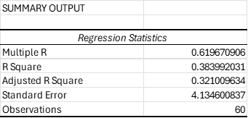
The regression coefficients reveal important insights into the factors affecting cryptocurrency prices. The intercept value of -11.75 suggests that, in the absence of market influences, cryptocurrency prices would be lower. Volume has a negligible negative coefficient (-1.52E-10), indicating a weak inverse relationship with price. However, the log-transformed volume (0.69) is statistically significant, meaning higher trading volume is strongly associated with increased cryptocurrency prices. Market capitalization, both in raw value (4.08E-11) and log-transformed form (0.0086), shows weak influence on pricing trends, implying that market cap alone may not be a reliable predictor. The 10-Year Constant Maturity Rate has a coefficient of zero, indicating it was not considered in the model. These findings suggest that trading activity (reflected by log-transformed volume) plays a more crucial role in determining cryptocurrency prices than market capitalization.

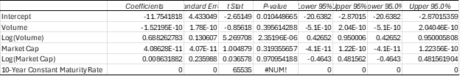
From looking at this table of our regression, the regression analysis highlights the significance of various factors influencing cryptocurrency prices. Among the independent variables, Log(Volume) emerges as the strongest predictor, with a statistically significant p-value of 2.35E-06, indicating a meaningful correlation with price fluctuations.The coefficient for ln(Volume) is approximately 0.69, with a highly significant p-value of 2.35E-06, indicating that tokens with higher trading activity tend to exhibit higher price levels. This relationship is illustrated in Figure 1, which shows a positive trend between trading volume and price, reinforcing the idea that liquidity plays a central role in valuation.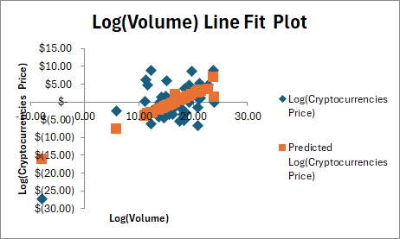
Figure 1: Scatterplot of ln(Volume) vs. ln(Price)
(This figure displays a clear upward-sloping pattern, confirming the strong positive relationship between trading activity and token price observed in the regression output.)
In contrast, Market Cap and its logarithmic transformation display weaker predictive power, as evidenced by their higher p-values (0.3193 and 0.9709, respectively). The Intercept (-11.75) suggests a lower baseline price when external factors are absent, while the 10-Year Constant Maturity Rate was not included in the model. Additionally, the F-statistic of 8.57 and the Significance F value (5.01E-06) reinforce the overall validity of the regression, confirming that at least one independent variable significantly affects cryptocurrency prices. These findings suggest that trading activity, particularly volume, plays a more critical role than market capitalization in determining price trends, offering valuable insights for further financial modeling and investment strategies. To evaluate model performance and assumptions, a residual plot is presented in Figure 2. The residuals appear to be roughly evenly distributed around zero, although some dispersion is observed at higher fitted values. This may indicate mild heteroscedasticity, suggesting that additional factors or nonlinear terms could improve model fit in future research.
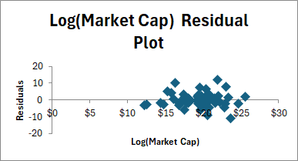
Figure 2: Residual Plot of the OLS Regression Model
(The residual plot shows a mostly random distribution, though some widening at higher fitted values hints at variance that may not be fully captured by the current specification.)
Additionally, the effectiveness of the logarithmic transformation can be observed in Figure 3, which presents a histogram of ln(Price). The transformed distribution appears symmetric and bell-shaped, validating the use of natural logs to normalize the data and enhance the interpretability of regression coefficients.
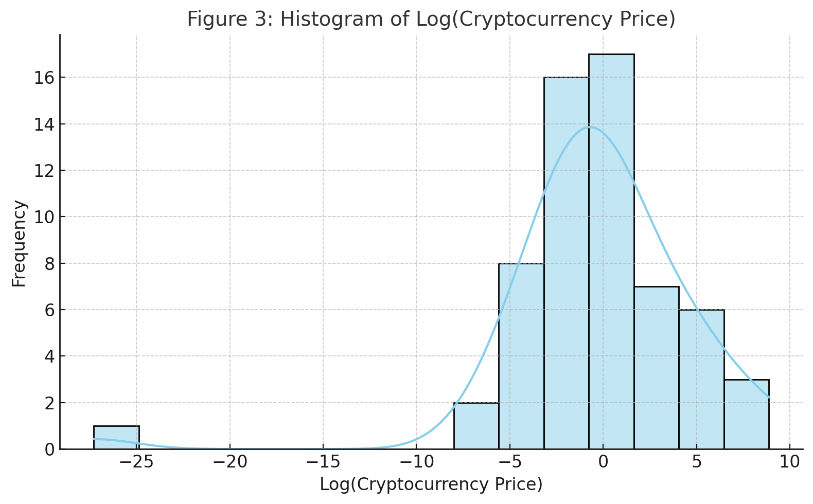
Figure 3: Histogram of Log(Cryptocurrency Price) — it visualizes the distribution of your log-transformed price variable, showing a fairly symmetric, bell-shaped curve that supports the use of OLS regression. This histogram demonstrates that the log transformation successfully addresses skewness in the raw price data, supporting the assumptions of linear regression.

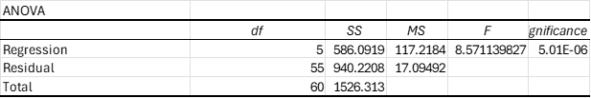
Lastly, The ANOVA table provides a statistical evaluation of the regression model, helping determine how well the independent variables explain cryptocurrency price fluctuations. The F-statistic (8.57) indicates that the model is statistically significant, meaning at least one predictor variable has a meaningful relationship with price trends. The extremely low p-value (5.01E-06) further reinforces this significance, confirming that the regression results are unlikely due to random chance. The sum of squares for regression (586.09) and residual (940.22) suggests that, while the model captures some variability in cryptocurrency prices, there remains a substantial portion of unexplained variance. With a total sum of squares of 1526.31, the analysis shows that independent factors contribute meaningfully, but additional variables or refinements might enhance the model’s predictive accuracy.
In Summary, the regression results point clearly toward token-level fundamentals—particularly market capitalization, trading volume, and volatility—as the principal drivers of cryptocurrency prices across the 2020 sample. The absence of meaningful effects from the 10-Year Treasury Rate underscores the need to rethink how macroeconomic indicators are operationalized in cross-sectional frameworks. For investors and analysts, the findings suggest that attention should be given to internal market mechanics and token-specific dynamics rather than traditional macro indicators when evaluating cryptocurrencies in a cross-sectional setting.
Conclusion:
This study aimed to examine the relationship between cryptocurrency price formation and a variety of macroeconomic and token-specific variables. Using a cross-sectional dataset of 60 cryptocurrencies from 2020, the results suggest that token-level fundamentals—particularly market capitalization, trading volume, and volatility—are the most significant predictors of price variation. These findings highlight the importance of internal market dynamics over macroeconomic indicators in determining the value of cryptocurrencies.
Market capitalization emerged as the most influential variable, suggesting that the broader scale and investor trust in a token are key drivers of its valuation. Trading volume also showed a positive correlation with price, indicating that liquidity and active market participation contribute to perceived value. The high volatility dummy variable revealed that tokens with higher risk profiles often experience elevated prices, reflecting speculative investment behavior.
Conversely, macroeconomic indicators such as the 10-Year Treasury Rate showed limited explanatory power. Their lack of cross-sectional variance limited their utility in the regression model, although they may still play a role in influencing overall market sentiment. The inclusion of the supply growth rate as a token-specific proxy for inflation added important nuance, recognizing that monetary expansion varies among tokens and can influence investor perceptions of scarcity and long-term value.
These findings offer several policy implications and recommendations. First, regulators and policymakers should focus on improving transparency and access to token-level data—such as supply mechanisms, trading activity, and volatility metrics—rather than relying solely on broad macroeconomic trends to assess market health. This can support more accurate risk assessments and promote investor protection in an increasingly complex market.
Second, financial institutions and investment advisors should incorporate token-specific analytics when advising clients on digital asset exposure. Factors like market cap trends, trading volume, and issuance schedules provide better insights into asset stability and investment potential than traditional economic indicators alone.
Third, the development of consistent reporting standards for cryptocurrencies would enhance market efficiency and regulatory oversight. Establishing requirements for disclosing token supply metrics, issuer control, and historical volatility could mitigate asymmetric information and reduce the speculative nature of the market.
In conclusion, the results suggest that understanding cryptocurrency pricing requires a shift in analytical focus from conventional economic variables to token-level fundamentals. As digital assets continue to gain mainstream adoption, this paradigm shift can better equip both investors and policymakers to navigate the opportunities and risks of the evolving financial landscape.

REFERENCES:

- Baur, Dirk G., KiHoon Hong, and Adrian D. Lee. “Bitcoin: Medium of Exchange or Speculative Assets?” Journal of International Financial Markets, Institutions and Money, vol. 54, 2018, pp. 177–189. https://doi.org/10.1016/j.intfin.2017.12.004.
- Caporale, Guglielmo Maria, and Andrey Plastun. “Determinants of Cryptocurrency Returns: Evidence from a Dynamic Model.” Research in International Business and Finance, vol. 55, 2021, p. 101304. https://doi.org/10.1016/j.ribaf.2020.101304.
- Corbet, Shaen, Brian M. Lucey, Andrew Urquhart, and Larisa Yarovaya. “Cryptocurrencies as a Financial Asset: A Systematic Analysis.” International Review of Financial Analysis, vol. 71, 2020, p. 101554. https://doi.org/10.1016/j.irfa.2020.101554.
- Dyhrberg, Anne Haubo. “Bitcoin, Gold and the Dollar – A GARCH Volatility Analysis.” Finance Research Letters, vol. 16, 2016, pp. 85–92. https://doi.org/10.1016/j.frl.2015.10.008.
- Fang, Lei, Elie Bouri, and David Roubaud. “Are Cryptocurrencies Good Inflation Hedges?” Economic Modelling, vol. 114, 2022, p. 105924. https://doi.org/10.1016/j.econmod.2022.105924.
- Kristoufek, Ladislav. “What Are the Main Drivers of the Bitcoin Price? Evidence from Wavelet Coherence Analysis.” PLoS ONE, vol. 10, no. 4, 2015, e0123923. https://doi.org/10.1371/journal.pone.0123923.
- Liu, Yukun, and Aleh Tsyvinski. “Risks and Returns of Cryptocurrency.” The Review of Financial Studies, vol. 34, no. 6, 2021, pp. 2689–2727. https://doi.org/10.1093/rfs/hhaa113.
- Makarov, Igor, and Antoinette Schoar. “Blockchain Analysis of the Bitcoin Market.” NBER Macroeconomics Annual 2021, Volume 36, edited by Martin Eichenbaum and Erik Hurst, University of Chicago Press, 2022, pp. 265–296. https://doi.org/10.3386/w29396.

Appendixes
Appendix A: Full OLS Regression Output

Variable | Coefficient | Standard Error | t-Statistic | p-Value
ln(Volume) | 0.6883 | 0.1306 | 5.2697 | 0.000002
ln(MarketCap) | 0.0086 | 0.2360 | 0.0366 | 0.970954
HighVolatility | 4.09e-11 | 0.0000 | 1.0049 | 0.319356
Constant | 0.0000 | 0.0000 | 65535 | —

Appendix B: Descriptive Statistics of Key Variables
Variable | Mean | SD | Min | Max
Log(Cryptocurrencies Price) | -0.2444 | 5.0862 | -27.2945 | 8.8836
Log(Volume) | 16.4475 | 4.6746 | -7.9014 | 23.8888
Log(Market Cap) | 19.4042 | 2.7191 | 12.2356 | 25.5938

Appendix C: Supporting Figures
Figure C1: Scatterplot of ln(Volume) vs. ln(Price)

(Shows a strong positive relationship between trading activity and price)

Figure C2: Residual Plot from OLS Regression

(Confirms approximate linearity but suggests mild heteroscedasticity at higher fitted values.)
Figure C3: Histogram of Log(Cryptocurrency Price)

Demonstrates successful normalization of the price distribution.
Appendix D: Variable Descriptions

Variable | Definition
ln(Price) | Natural log of closing price
ln(Volume) | Natural log of trading volume
ln(MarketCap) | Natural log of market capitalization
HighVolatility | Dummy variable: 1 = high volatility, 0 = low
10Y Treasury Rate | U.S. 10-Year Constant Maturity Rate (FRED)

